**Linux And Security Article**

Task 01. Installation of MySQL and Service Status

a. sudo apt-get install mysql-client

b. sudo apt-get install mysql-server

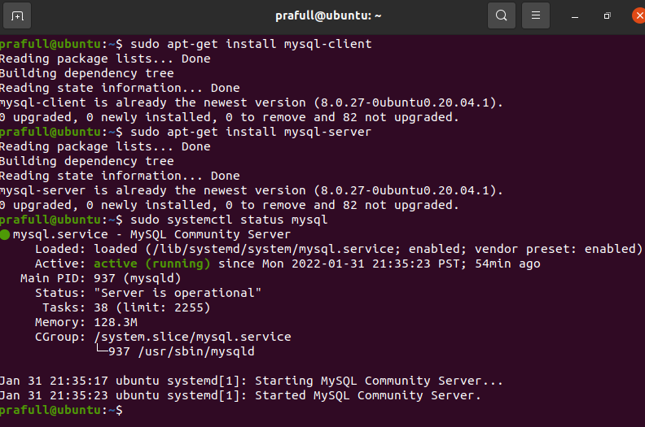

Task 02. Running Python code on linux

1. Installation of python # sudo apt-get install python3
2. Installation of gedit # sudo apt-get install gedit
3. Write python code # gedit Python1.py
4. Run python code # python3 python1.py

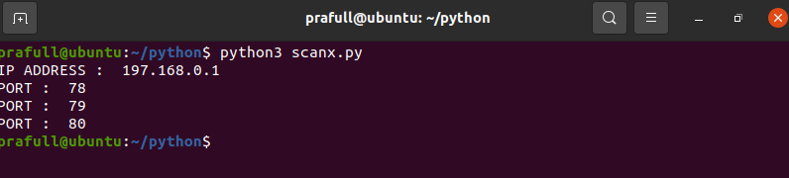

Task 03. Bash Shell Programming

1. Install the editor #sudo apt-get install gedit
2. Write the code for shell file #gedit first.sh

* # !/bin/sh
* Write any code i.e ipconfig or netstat -ano etc

1. Save file (.sh) and execute (2 ways)

(i) - bash first.sh

(ii) - chmod +x first.sh

./first.ch

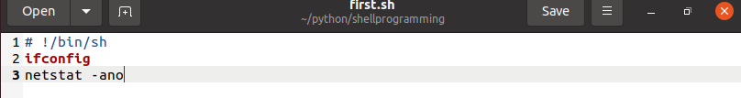

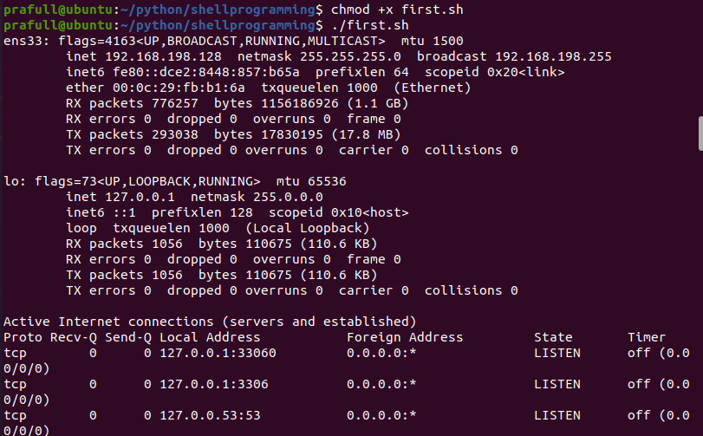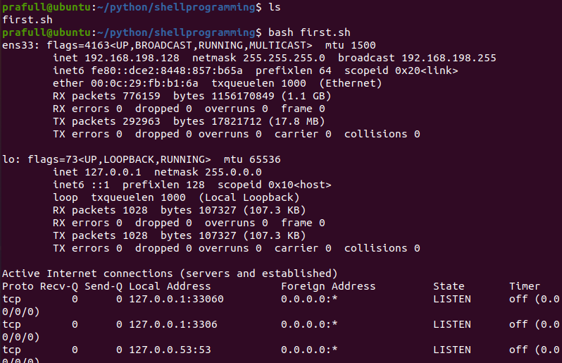

Task 04.Kernal Programming

1. Create a directory Kernel programming

#mkdir kernel _programming

#cd kernel_programming

1. Clone repository

#sudo apt-get install git

#git clone ….paste the link from github here….

1. Update necessary headers and dependencies from details in the repository

#sudo apt-get install build-essential linux-header-$(uname -r)

#sudo apt install bino

#sudo apt install flex

1. Write C-programming code include header files and save with ,c extension #gedit hello.c

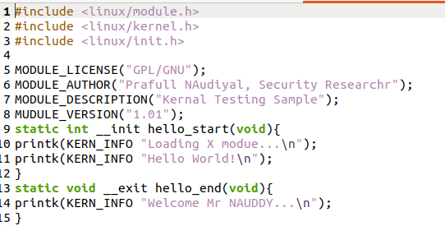

1. Write makefile and name if “makefile” no extension needed #gedit makefile

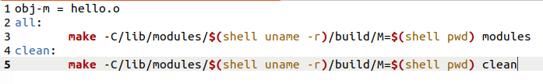

1. Run make #sudo make
2. Run makeinfo to get details #makeinfo hello.ko
3. Inserting mod file #insmod hello.ko , lsmod

Take 05.